Urinary Iodine Ammonium Persulfate Method
Advantages of the method
- Safe digestion process
- Simple manual method
- Avoids expensive or sophisticated instrumentation
- Reagents can be made in the laboratory, so the method is not reliant on diagnostic suppliers
- Good performance characteristics
- Cost effective and sustainable
Reagents and Calibrants
Reagents were prepared as described by Pino (1). Our first modification to Pino’s method involved the preparation of the standard solutions. The stock standard solution was prepared by adding 0.840 g of KIO₃ (Sigma) is dissolved in 18 M water to a final volume of 500mL in a volumetric flask with a final concentration of 1000mg/L. The 100mg/L working stock solution is prepared by adding 10ml of the stock solution to 100ml 18 M water. Bench stock standards are then prepared by adding aliquots of
50, 100, 150, 200, 250, 300L each diluted to a final volume of 100 mL, corresponding respectively to iodine concentration of 50, 100, 150, 200, 250, and 300g/L. These bench standards have been shown in this laboratory to be stable for one month, stored at 0°C. After the bench standards have been allowed to reach room temperature the working calibrators are prepared by pipeting 250L of each standard into a 13x100mm test tube.
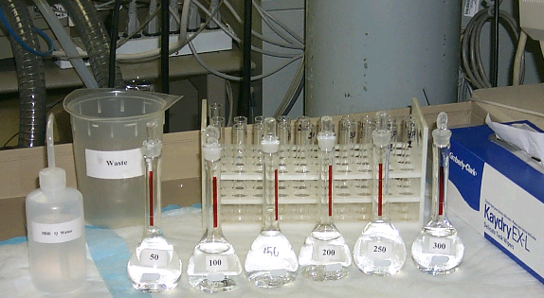

Bench stock standards.
Solutions
- Ammonium persulfate solution
Dissolve 228.2g (NH₄)₂S₂0₈ in 1L H₂0. Store in darkness, stable for 6 months.

- Arsenious acid solution
Place 5g As₂0₃ and 25g NaCl, in a clean 1L volumetric flask, then add 200mL 5NH₂S0₄. Add H₂0 to about 500mL, heat gently with stirring to dissolve, then cool to room temperature. Dilute with H₂0to 1L. Store in darkness, stable for 6 months.

- Ceric ammonium sulfate solution
Dissolve 24g ceric ammonium sulfate in 1L 3.5N H₂S0₄ . Make up at least 24hours before use, and store in darkness, stable for 6 months.

(4) Iodine standard - See above

Procedure

The ammonium persulfate method procedure involves the following steps. Mix 250µL of the urine sample to suspend any sediment evenly, then pipette 250L of each, calibrator, quality control and sample into a 13x100mm test tube. Add 1ml of ammonium persulfate solution to each tube, mix, and digest on a heating block for 60min at 91-95°C. After digestion cool tubes to room temperature, then add 3.5ml arsenious acid solution, mix and stand for 15 minutes. Add 400L ceric ammonium sulfate solution to each tube and quickly mix by vortex or other means. A timer should be used to keep a constant interval 30sec., between additions to successive tubes. Exactly 30min after addition of ceric ammonium sulfate to the first tube, read its absorbency at 420m in a spectrophotometer (Spectronic 20D+). It is necessary to rinse the cuvette between each successive reading, to avoid carryover, which ultimately contributes to the nonlinearity of standard curves.

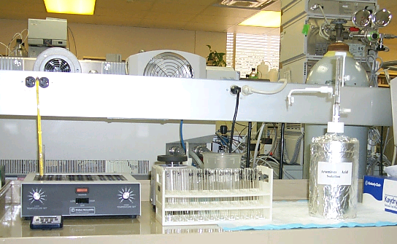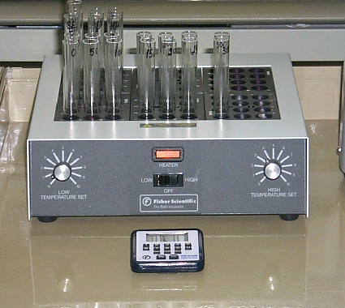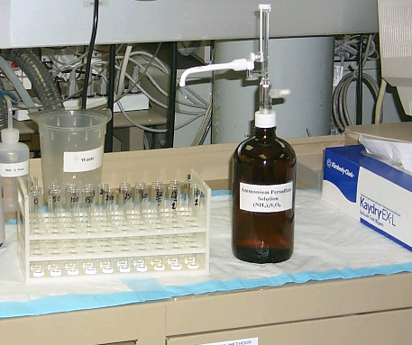Ammonium Persulfate Heating block with timer

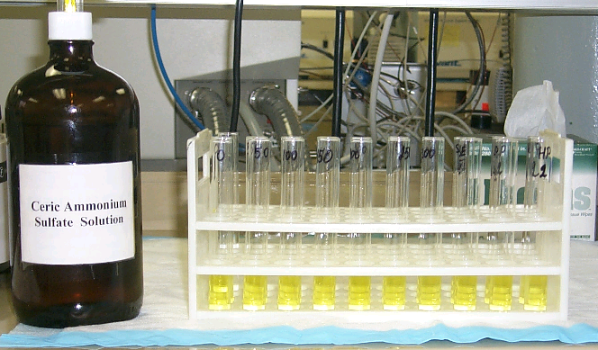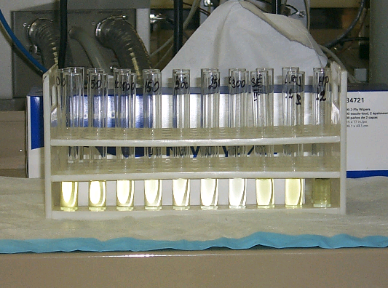

Add 3.5 mL Arsenious Acid Solution

Add 400 μL Cerric Ammonium Sulfate Solution

After standing for 30 minutes
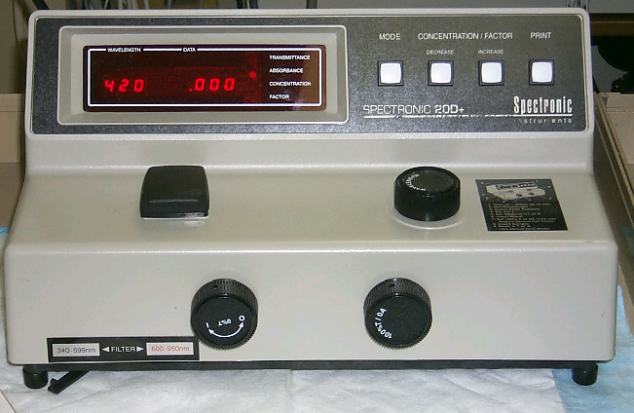

Spectrophometer at 420 nm

REFERENCES

- Pino S, Fang S, Braverman LE. Ammonium persulfate: a safe alternative oxidizing reagent for measuring urinary iodine. Clinical Chemistry 1996; 42:2; 239-243.

Use of trade names and commercial sources is for identification only and does not imply an endorsement by the U.S. Department of Health and Human Services (DHHS) and the Centers for Disease Control and Prevention (CDC).

