Table 1: Summary of labels and markings required for safe and proper shipping of different types of packages

Package Type: | 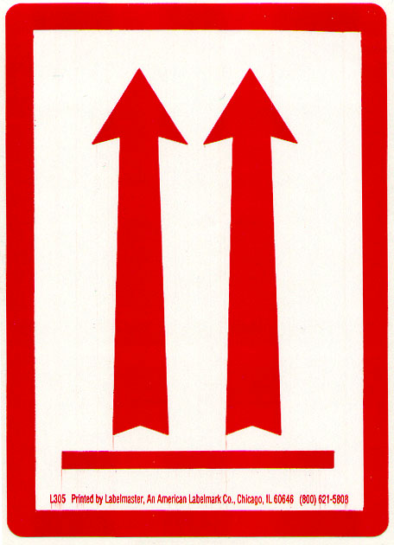 | 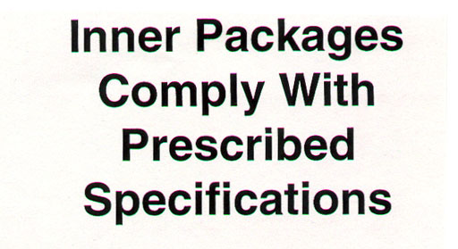 | 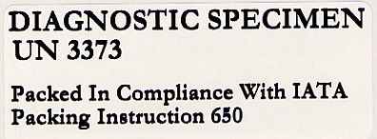 | 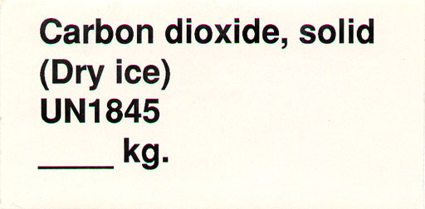  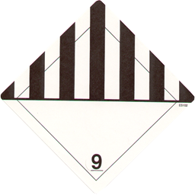 | 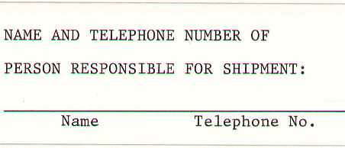  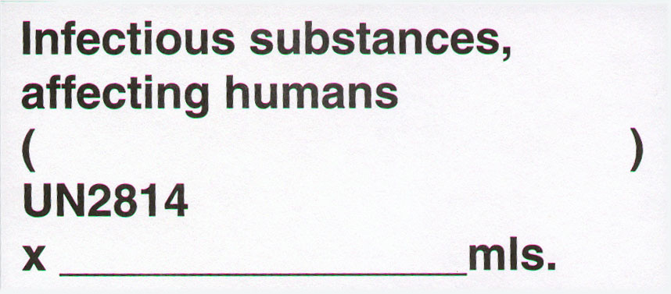  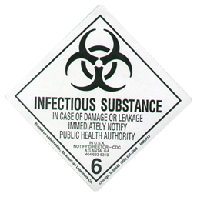 | 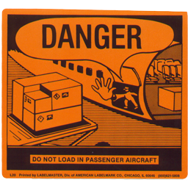 | (Figure within Table)
Diagnostic Specimens | √ |  | √ |  |  |  | Fig A
Diagnostic Specimens on Dry Ice | √ |  | √ | √ |  |  | Fig B
Infectious Substance
…with less than 50mls | √ | √ * |  |  | √ |  | Fig C
…with more than 50mls | √ | √ * |  |  | √ | √ | Fig D
Infectious Substance on Dry Ice
…with less than 50mls | √ | √ * |  | √ | √ |  | Fig E
…with more than 50mls | √ | √ * |  | √ | √ | √ | Fig F
Dry Ice | √ |  |  | √ |  |  | Fig G
* If overpack used

Table 2: Description of individual labels and markings required for safe and proper shipping of different types of packages

This orientation label should clearly mark which side is ‘Up’. Two labels are required on all boxes, each one on opposite sides of the package.
This marking must appear on an overpack when the regulations require the use of packagings bearing UN Specification Markings.
This marking is required when shipping Diagnostic Specimens.
These two labels are required when shipping a substance or specimen on Dry Ice.
These three labels are required when shipping Infectious Substances. Please note when shipping Infectious Substances you must use UN certified 6.2 Infectious Substances Packaging.
This label is required when shipping more than 50mls of an Infectious Substance.
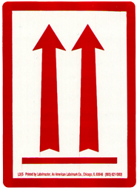
Figure A: Package with diagnostic specimens
Must have two “up” arrows on opposite sides
Surface to which air waybill and/or address labels are affixed

Figure B: Package with diagnostic specimens on dry ice
Must have two “up” arrows on opposite sides
Surface to which air waybill and/or address labels are affixed

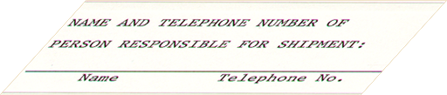
Figure C: Overpack with <50 ml of infectious substance
Must have two “up” arrows on opposite sides
You must use UN certified 6.2 Infectious Substances Packaging.

Surface to which air waybill and/or address labels are affixed
Label indicating name and telephone number of person responsible for shipment

Figure D: Overpack with ≥50 ml of infectious substance
Must have two “up” arrows on opposite sides
You must use UN certified 6.2 Infectious Substances Packaging.
Surface to which air waybill and/or address labels are affixed

Label indicating name and telephone number of person responsible for shipment

Figure E: Overpack with <50 ml infectious substance and dry ice
Must have two “up” arrows on opposite sides
You must use UN certified 6.2 Infectious Substances Packaging.

Surface to which air waybill and/or address labels are affixed
Label indicating name and telephone number of person responsible for shipment

Figure F: Overpack with ≥50 ml infectious substance and dry ice
Must have two “up” arrows on opposite sides
You must use UN certified 6.2 Infectious Substances Packaging.

Surface to which air waybill and/or address labels are affixed

Label indicating name and telephone number of person responsible for shipment

Figure G: Appropriate labeling of packages containing dry ice
Must have two “up” arrows on opposite sides
Surface to which air waybill and/or address labels are affixed

